Day 14 Output:

Initial Page:

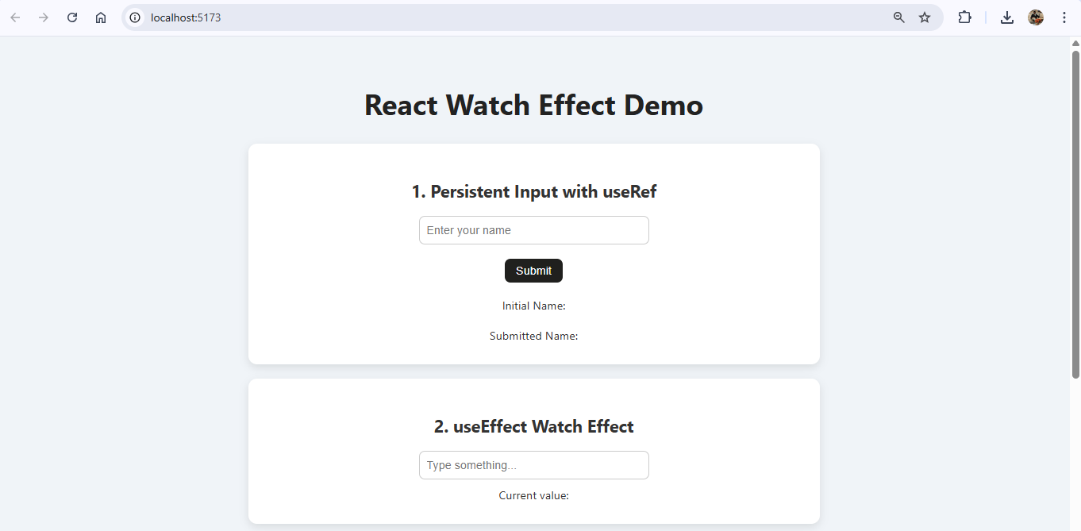

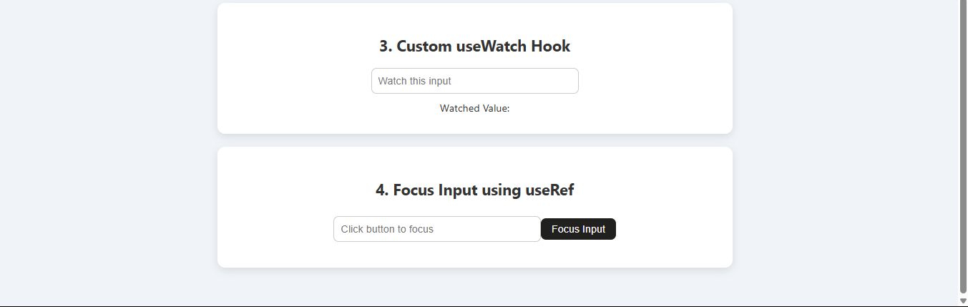

Giving input:

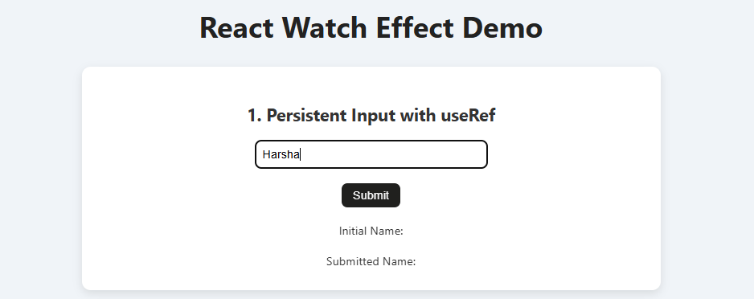

After taking input:

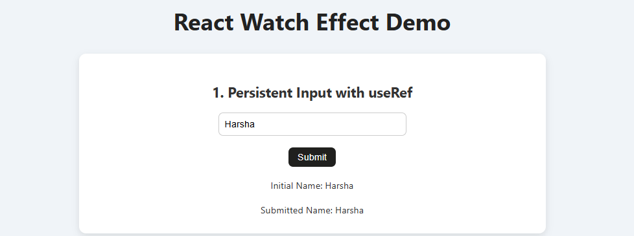

Watch effect:

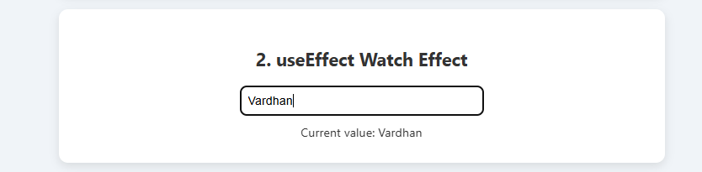

useWatch hook:

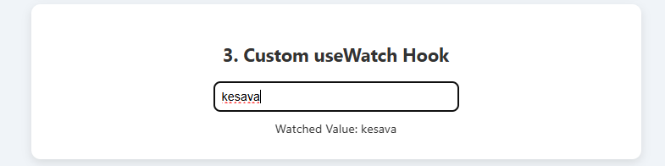

4.Focus input:

